Bottom trawl survey age and length composition input sample sizes for stocks assessed with statistical catch-at-age assessment models at the Alaska Fisheries Science Center

by

Peter-John F. Hulson1,*, Benjamin C. Williams1, Matthew R. Siskey4, Meaghan D. Bryan2, and Jason Conner3

1 Auke Bay Laboratories, Alaska Fisheries Science Center, National Marine Fisheries Service, National Oceanic and Atmospheric Administration, 17109 Point Lena Loop Rd., Juneau, AK 99801  
2 Resource Ecology and Fisheries Management Division, Alaska Fisheries Science Center, National Marine Fisheries Service, National Oceanic and Atmospheric Administration, 7600 Sand Point Way NE, Seattle, WA 98115  
3 Resource Assessment and Conservation Engineering Division, Alaska Fisheries Science Center, National Marine Fisheries Service, National Oceanic and Atmospheric Administration, 7600 Sand Point Way NE, Seattle, WA 98115  
4 Washington Department of Fish and Wildlife, 1111 Washington St. SE, Olympia, WA 98501

* Correspondence: [Peter-John F. Hulson <[pete.hulson@noaa.gov](mailto:pete.hulson@noaa.gov)>](mailto:pete.hulson@noaa.gov)

Month 2023

# ABSTRACT

At the Alaska Fisheries Science Center (AFSC) a number of fish stocks are assessed using statistical catch-at-age (SCA) models. SCA models integrate various sources of data to inform estimation of population dynamics and management quantities for fisheries that target these stocks. Two important information sources are age and length composition data from fishery-independent (survey) and fishery-dependent sources. When used in SCA models, age and length composition data require determining *a priori* the ‘input sample size’ to weight their relative information content against other data sources fit within the assessment model. We developed an R-package that uses bootstrap methods originally presented in Stewart and Hamel (2014) to estimate input sample size for age and length composition data from bottom trawl surveys conducted by the AFSC in the eastern Bering Sea, Aleutian Islands, and Gulf of Alaska. Here we present annual input sample size estimates for length and age compositions (including sex-specific and sex combined compositions, and sub-regional compositions within the Gulf of Alaska) collected during Alaska bottom trawl surveys. These new input sample size estimates provide an objective method that follows the sampling design of the bottom trawl surveys for fishery stock assessments. We recommend that these input sample size estimates become a standard bottom trawl survey data product that are updated annually and available to assessment authors for inclusion into AFSC fishery stock assessments. Software provided can also be used on a less-frequent basis for research to explore the consequences of changes in sampling design or intensity.

# CONTENTS

Introduction

Materials and Methods

Survey Data

Expanding Length Frequency to Population Abundance-at-Length

Expanding Specimen Collections to Population Abundance-at-Age

[Bootstrap Framework for Estimating Age and Length Composition   
 Input Sample Size](#X9d806696d317e285f11de36862fb1be375c329b)

Computing Effective and Input Sample Size

Evaluation and Presentation of Input Sample Size

Results

Discussion

Acknowledgments

Citations

# INTRODUCTION

Under the North Pacific Fishery Management Council (NPFMC) Fishery Management Plan (FMP) for the Eastern Bering Sea, Aleutian Islands, and Gulf of Alaska, Tier 1–3 stocks use statistical catch-at-age assessment models to estimate population and management quantities (NPFMC 2020a, 2020b). While these models can vary in their specific implementation across stocks (i.e., due to differences in parameterization, error structures, or data availability), a critical and ubiquitous data component is age and length composition data. Age and length composition data are collected on both fishery-independent (e.g., bottom trawl or longline surveys) and fishery-dependent platforms, providing critical data to assessments in order to track population changes over time. The National Oceanic and Atmospheric Administration’s (NOAA) Alaska Fisheries Science Center (AFSC) operates fishery-independent bottom trawl surveys (Stauffer 2004) that span most of the continental shelf and a portion of the continental slope for federal waters off Alaska. Proceeding southward from the Bering Strait, these waters include the eastern Bering Sea (EBS), the Aleutian Islands (AI), and the Gulf of Alaska (GOA). These surveys provide age and length composition data for 26 stocks (or stock complexes) assessed or updated on a pre-established and frequent cycle with statistical catch-at-age models.

At the AFSC, age and length frequency sampling from bottom trawl surveys is used in stock assessment models in many ways to inform estimates of population abundance that are subsequently used to set management quantities, as well as stock status that is used nationally to measure agency success on legislative mandates. The most common use of length frequency sampling at the AFSC is to derive estimates of the population abundance-at-length that are used in conjunction with an age-length key to estimate population estimates at age, which are then converted to age composition (i.e., proportions-at-age) and fit in the model (e.g., Monnahan et al. 2021, Spencer and Ianelli 2022). Length frequency samples are also used in many assessments in a conditional-age-at-length framework (Rudd et al. 2021) that both fit the length compositions and enables estimation of growth internally to the assessment (e.g., McGilliard and Palsson 2017). In some cases, where age data are not available, length frequency samples that have been expanded to population abundance-at-length estimates are used directly as composition data (i.e., proportions-at-length) within the assessment (e.g., McGilliard et al. 2019). Finally, recent developments have incorporated length frequency samples in a model-based framework to estimate length and age composition that are subsequently integrated into the assessment model (Thorson and Haltuch 2019, Ianelli et al. 2021, Thompson et al. 2021).

Predominantly, the multinomial likelihood is used to fit age and length composition data at the AFSC (e.g., Bryan and Palsson 2021), while recently the Dirichlet-Multinomial has also been explored (e.g., Barbeaux et al. 2022). A common requirement, regardless of the likelihood employed, is a pre-determination of the input sample size that is used to ‘weight’ each year’s age or length composition data. This weight subsequently influences the precision of the assessment model’s fit to the particular composition data. Over the years, a variety of approaches have been used at AFSC to set the input sample size in stock assessments. These include selecting a constant value (e.g., Hulson et al. 2022), relating the input sample size to the number of hauls from which age or length composition data was collected (e.g., Spencer and Ianelli 2022), relating the input sample size to the nominal sample size (e.g., Hulson et al. 2021), or relating the input sample size to some combination of hauls and nominal sample size (e.g., Williams et al. 2022). Overall, there is no consensus method that is agreed upon at the AFSC to determine input sample size.

Stewart and Hamel (2014) introduced a method in which bootstrap techniques were used to resample age and length composition data that provides an estimate of the input sample size that can be used within assessment models. The primary advantage of this method is that it provides an objective framework from which estimates of input sample size are obtained that mimics the sampling design employed (i.e., design-based estimation), either from a fishery-independent survey or on fishery-dependent platforms. Other methods have also been developed, including model-based (Thorson 2014, Thorson et al. 2017) or methods that combine design and model-based elements (Miller and Skalski 2006). Here, we apply the methods of Stewart and Hamel (2014) to obtain annual estimates of input sample size for age and length composition data obtained by the AFSC bottom trawl surveys in the EBS, AI, and GOA for all stocks assessed at AFSC with statistical catch-at-age assessment models. The main objectives of this technical memorandum are to 1) document methods used by AFSC for expanding length and age collections to population abundance estimates (which are subsequently used as composition data in stock assessments), 2) present stock-specific results of input samples size from AFSC bottom trawl surveys for Tier 1–3 stocks, and 3) record methods for estimating input sample sizes of survey-based age and length compositions using a two-stage bootstrapping approach.

# MATERIALS AND METHODS

## Survey Data

Data collection for each AFSC groundfish survey is described in NOAA Technical Memoranda (EBS: Lauth et al. 2019, AI: von Szalay et al. 2017, GOA: von Szalay and Raring 2018). Length frequency protocols and a recent analysis of sex-specific length frequency data are further described in Hulson et al. (2023). To facilitate age estimation, individual fish are processed at sea; sex, length and weight are recorded and sagittal otoliths are extracted and returned to the AFSC’s Age and Growth laboratory for age determination. Survey age sampling protocols are species-specific and follow 1 of 2 paradigms: 1) a stratified collection distributed over both the survey’s spatial extent and the expected size range of the species; or 2) a small subsample (3-6 fish, species-dependent) collected randomly (i.e., no size-stratification) per haul. The protocol for some species has changed over the time series, which has followed a trend of transitioning from protocol 1) (stratified sampling) to protocol 2) (random sample).

Species collected on each survey that are assessed with statistical catch-at-age models were selected to be included in this analysis (Tier 1–3 stock assessments, Table 1). Data from AFSC bottom trawl surveys conducted in the EBS shelf (1982 to present), EBS slope (2002, 2004, 2008, 2010, 2012, and 2016), AI (triennially from 1991 to 2000, biennially from 2000 to present with the exception of 2008 and 2020 in which no surveys took place), and GOA (triennially from 1990 to 1999, biennially from 1999 to present) that are employed in the stock assessment models for each respective area were used in this study to estimate input sample size with a bootstrap estimator. The bootstrap estimator is designed to be a standardized tool for generating input sample sizes and the input sample sizes generated with it are intended to be used to weight length and age composition data in future stock assessments.

## Expanding Length Frequency to Population Abundance-at-Length

Length frequency samples collected by the AFSC bottom trawl surveys are expanded by catch and stratum area to obtain estimates of population abundance-at-length (this approach is also detailed in Hulson et al. (2023).We include the description here to provide a source for both the length and age expansions). This is often referred to as the ‘first stage expansion’ and is a common method to obtain population abundance estimates at length from area-swept survey data (Miller and Skalski 2006; e.g., Ailloud and Hoenig 2019). Population abundance-at-length is computed for three sex categories at the stratum level: males, females, and unsexed; these estimates are then summed across strata to obtain the population abundance-at-length for the management-scale region (i.e., EBS, AI, or GOA). However, these estimates can also be summed to any sub-region level. To expand the species-specific length frequency samples to population-at-length we first compute the overall numbers within a stratum by multiplying the average catch per unit effort within the strata (i.e., the number of fish per square kilometer averaged across the hauls performed within the strata) by the area of the strata (in square kilometers). We then compute the relative catch per unit effort for each haul performed within the strata and the sex-specific relative length frequency for each haul. The expanded population-at-length is obtained by multiplying the numbers within the strata, the relative catch per unit effort of each haul, and the sex-specific relative length frequency. This process is shown in mathematical form in the following.

In the first step of this process, we compute the overall population numbers in year-*y* within stratum-*st* () with

where is the area of stratum-*s* (in km2), and is the species-specific average catch per unit effort of numbers captured across the hauls within a strata in year-*y*, given by

where is the number of hauls conduscted in stratum-*s* in year-*y*, is the catch per unit effort (i.e, numbers caught divided by effort) within a haul-*h*, is the catch (in numbers) in haul-*h* for stratum-*s* in year-*y*, and is the effort in haul-*h* for stratum-*s* in year-*y*. Effort is computed as the net width multiplied by the distance the trawl was in contact with the seafloor, or, the area swept by the haul (in km2). Next, the proportion of catch per unit effort among hauls () is computed by

where is the catch per unit effort of numbers caught within a haul-*h* for stratum-*s* in year-*y*. We then compute the sex-specific proportion of the total number of lengths sampled within a haul by length () with

where is the length frequency sampled, in numbers, by sex-*x* and length-*l* (in cm) within a haul-*h* for stratum-*s* in year-*y*. In some hauls that have catch for a species there is no length frequency data that were collected (i.e., ); this occurs infrequently but does occur in the historical data. When this occurs, case (2) is applied in (4), where the data are pooled for each sex across all the hauls conducted and used in place of the missing length frequency data for that haul to account for the unknown length frequency in these hauls. Otherwise, if length frequency samples are obtained, case (1) is applied. Finally, we estimate the sex-specific population abundance-at-length within strata-*s* with

and to obtain the sex-specific estimates of population abundance-at-length in a management area one would simply sum across strata.

## Expanding Specimen Collections to Population Abundance-at-Age

In the second stage expansion the sex-specific estimates of population abundance-at-length are used to estimate sex-specific population abundance-at-age. The annual specimen data that are collected during the survey, which include observations of age-at-length, are first populated into sex-specific numbers at age and length (). Next, the sex-specific numbers-at-age and length are converted to sex-specific proportions of age-at-length (i.e., age-length key) with

The proportions of age-at-length are then expanded to population abundance-at-age with

where is the population abundance-at-length from (5) summed across strata. For specimen age data with observations of sex (either female or male), the sex-specific specimen age data are used. However, for specimen age data without observations of sex, the specimen age data are pooled across all sexes and the unsexed population abundance-at-length is then applied to the pooled specimen data to estimate unsexed population abundance-at-age.

Two general categories of special cases for several stock assessments were also included in our analysis: 1) spatially-explicit assessments, and 2) assessments of species complexes. Population abundance-at-age estimates are computed at the management area scale (e.g., the entire GOA, AI, or EBS) for the majority of stocks assessed at AFSC; however, we note that there are two flatfish stock assessments that are spatially-explicit in the GOA (McGilliard and Palsson 2017, Bryan and Palsson 2021). While in the preceding equations we do not include a subscript for sub-region, population abundance-at-age can be estimated by sub-region by summing the population abundance-at-length in equation (5) across selected strata within the region that correspond to the sub-region and applying equations (6) and (7) to specimen age data that are subsetted to the sub-region. We have developed functions to estimate population abundance-at-age by sub-region, and by a combination of sub-regions within the GOA to allow for this flexibility in estimating population abundance-at-age.

There are two stock complexes managed by AFSC in which the species are combined and assessed within the same statistical catch-at-age model: blackspotted and rougheye rockfish in the GOA and AI (Spencer et al. 2020, Sullivan et al. 2021). Between the two management regions there is a subtle differences in how the population abundance-at-age is estimated from the survey specimen age data. The difference between each region is that complex specimen age data are pooled prior to age expansion (Spencer et al. 2020), or the specimen age data are not pooled and population-at-age for each species are summed after expansion (Sullivan et al. 2021). We have developed functions that allow for these differences and estimate population abundance-at-age for these two stock complexes. In a similar case, while not assessed as a complex, over the historical bottom trawl survey in the GOA several species codes have been used for dusky rockfish. We have also developed a custom function that estimates population abundance-at-length and age for this case.

## Bootstrap Framework for Estimating Age and Length Composition Input Sample Size

To estimate the historical input sample sizes for age and length compositions of stocks assessed at AFSC, we developed a nonparameteric bootstrap framework based on the methodology outlined in Stewart and Hamel (2014) and expanding on recent work (Siskey et al. 2023). The bootstrap framework is composed of a suite of nested resampling (with replacement) protocols. Functions to run the sampling protocols were developed in a compartmentalized manner to provide for flexibility in exploring desired resampling protocols. The order of operations (Fig. 1) has the following schedule, with steps 1-3 being optional switches (so that the uncertainty that results from resampling at each step can be tested):

1. Resample hauls from the set of hauls with associated catch per unit effort (in numbers)
2. Within the resampled hauls from step 1, resample the observed length frequency data
3. Within the resampled hauls from step 1, resample the observed specimen data
4. From the resampled length frequency data in step 2, calculate sex-specific population abundance-at-length, using equations (1) - (5)
5. From the resampled specimen age data in step 3 and the sex-specific population abundance-at-length in step 4, calculate sex-specific population abundance-at-age, using equations (6) - (7)

Steps 1-5 were repeated iteratively, providing sex-specific population abundance-at-length and age that was then compared to the observed sex-specific population abundance-at-length and age as from the bottom trawl surveys. We completed 500 iterations of the bootstrap-simulation, variability in the population abundance-at-length had stabilized at that point. The bootstrap-simulation was developed in R (R Core Team 2022) and is available via GitHub as an R package (<https://github.com/BenWilliams-NOAA/surveyISS>).

## Computing Effective and Input Sample Size

Realized sample size (), as introduced by McAllister and Ianelli (1997), is a statistic that can evaluate the level of intra-haul correlation in age or length composition samples that are collected on a survey. It is also a statistic that can evaluate the amount of uncertainty in an estimated composition compared to an observed composition. Realized sample size is given by

where is the estimated proportion for category-*c* (which can be either age or length or any other arbitrary category across which proportions are computed) and is the observed proportion. A higher indicates less uncertainty in the composition estimates, while a lower indicates more uncertainty.

In this bootstrap-simulation, we used realized sample size to calculate uncertainty in length compositions for each simulation iteration, where the underlying age and length compositions derived from the historical bottom trawl surveys were treated as the observed proportions in equation (8). For each iteration of the bootstrapped survey data, we computed a sex-specific estimated proportion () that was then compared to the underlying historical sex-specific age and length composition (the realized sample size for the total age and length composition was also computed as the sum of population abundance-at-age and length). Thus, for each iteration of the simulation, we computed a realized sample size that quantifies the amount of uncertainty that resulted from that iteration of sub-sampling sexed length frequency data. This resulted in distributions of realized sample size for each stock, each sex, and each sub-region of interest

Input sample size () is defined as a metric of uncertainty used in data-weighting procedures for stock assessment models. An input sample size is usually assigned to annual length compositions in the model fitting process, but there are a variety of methods for calculation and are closely related to the information content of the data product in question. To summarize uncertainty across bootstrap iterations of , we calculated as the harmonic mean of realized sample size across bootstrap iterations

where is the annual input sample size, is the realized sample size for iteration-*i*, and *I* is the total number of iterations for which the bootstrap procedure is run. The harmonic mean has been shown to reduce bias in recovering the true sample size in simulations for a multinomial distribution. Due to this reduction in bias the harmonic mean has also been recommended to determine the that is used in stock assessment models to fit compositional data (Stewart and Hamel 2014). Herein, we use the term ‘realized sample size or ’ to refer to the realized sample sizes that were computed for each iteration of the bootstrap-simulation from equation (8), and the term ‘input sample size or ’ to refer to the harmonic mean of the iterated realized sample sizes from equation (9).

## Evaluation and Presentation of Input Sample Size

To present the age and length composition as determined by the nonparameteric bootstrap procedure, we use bar-plots to show the annual results and box-plots to show the combined results across years (where the median, interquartile, and inter 95th percentile ranges are shown). We show these results across the surveys evaluated and for each sex-specific age and length composition so that the reader can refer to the general results as it pertains to their stock of interest; this also allows for general comparisons to be made across stocks. Because of the use of nominal sample size and sampled hauls as proxies for input sample size in a number of AFSC stock assessment models we provide scatter-plots that compare age composition to the number of otoliths aged and the number of hauls sampled for otoliths. We further explored the relationship between age composition and the number of sampled hauls by fitting a linear model, we present the values from these fits to indicate the strength of the relationships.

# RESULTS

Average age and length composition nominal sample sizes (i.e., number of length samples collected on deck or number of otoliths aged in the laboratory, rounded to the nearest 10s for age and 100s for length) for each species and year bottom trawl surveys evaluated are presented in Tables 2 - 3. Across the surveys, average sex-specific length frequency nominal sample size ranged from 300 to 35,600 samples per year, where the total length frequency nominal sample size (for all sexes combined) ranged from around 700–82,500 per year. The most frequently sampled species for length frequency within the EBS shelf survey were walleye pollock, yellowfin sole, northern rock sole, and arrowtooth flounder, while arrowtooth flounder, kamchatka flounder, and Pacific ocean perch were the most frequently sampled in the EBS slope survey (Table 2). The most frequently sampled species for length frequency within the Aleutian Islands bottom trawl survey were Pacific ocean perch, walleye pollock, and arrowtooth flounder and in the Gulf of Alaska bottom trawl survey were arrowtooth flounder, walleye pollock, flathead sole, and Pacific ocean perch (Table 3). Across the surveys, average sex-specific otolith nominal sample sizes ranged from 130 to 850 per year, while the total otolith nominal sample size (for all sexes combined) ranged from 290 to 1,550 per year. It was commonly the case that the most frequently sampled species in each survey for otoliths were the most frequently sampled species for length frequency.

The age and length composition output of the surveyISS package is structured by year, species (using the AFSC survey species code), sex, and region (an example of the output is presented in Table 4). Using walleye pollock total (combined sex) age composition as an example, is produced by year for each survey the stock is sampled from (Figure 2). Sex-specific yellowfin sole age composition from the EBS shelf survey composition is shown in Figure 3. For all species sampled in each survey, the range and median of total and sex-specific length composition across survey years is shown in Figure 4, and age composition is shown in Figure 5. Sub-regional for age and length composition can also be estimated within the GOA survey (Figs. 6 and 7). These results show that the length composition ranged from the hundreds to thousands and were larger than the age composition . Additionally, the sex-specific for either length or age composition were smaller than the for the total age compositions. For both the age and length compositions the magnitude was species-specific, and was closely related to the overall sampling intensity for age and length observations on the surveys.

For age composition (including sex-specific composition data), the was smaller than the sample sizes collected that were aged and there was a generally increasing trend between the number aged and (Fig. 8). The result of less than sample size was also true for length composition (results not shown). Comparing the age composition to the number of hauls from which age samples were obtained also resulted in a generally increasing trend, and the magnitude of and the number of sampled hauls was comparable (Fig. 9). The strength of the relationship between and the number of sampled hauls, in terms of the value from a linear model fit, was stock and region-specific (Tables 5 and 6). In general, the strongest relationship between age composition and the number of sampled hauls resulted for the flatfish stocks evaluated as compared to the gadid and rockfish stocks. Although, nearly 80% of the stock-composition type (female, male, and total) combinations resulted in values less than 0.75, and over 56% resulted in values less than 0.5, indicating that the relationship between age composition and the number of sampled hauls was generally weak.

# DISCUSSION

Here we have presented an application of the method outlined in Stewart and Hamel (2014) to produce annual age and length composition for fishery stocks assessed by AFSC with statistical catch-at-age models. We present results for the bottom trawl surveys conducted in the EBS shelf, slope, AI, and GOA by the AFSC with the hope that this will motivate the adoption of a standardized approach akin to ours for setting initial composition weights in future assessments. This application produces total (combined sex) and sex-specific , as well as sub-region within the GOA bottom trawl survey. We found that the magnitude of age and length compositions can vary across stocks and years, but in general, age composition ranged from the tens to hundreds (with an average age of around 100 across all years and species) and length composition ranged from the hundreds to thousands (with an average length of around 1,000 across all years and species). This is not surprising, given that the magnitude of sampling for length frequency is much larger than sampling for ages. We also found that the sex-specific is smaller than the total (combined sex) , which is also not surprising given the relatively smaller sampling intensity for sex-specific samples. We will note from this result that care and intentionality should be taken when developing and implementing sex-specific assessments given this increase in uncertainty in composition data.

At the AFSC, as noted previously, there are a myriad of approaches employed to set for age and length composition data used in assessments. There is no generally agreed upon approach; however, a common approach that has been implemented is to set as some function of the number of hauls. This follows from a result of Pennington et al. (2000) who found the age composition to be one per sampled haul. Herein we find that, while there is a generally increasing relationship between the number of sampled hauls and the age composition , and that the number of hauls and age composition are the same order of magnitude, the relationship between hauls and age composition is highly variable and not very strong. It is unclear as to the consequence of misspecification in AFSC assessments that use the number of sampled hauls as a proxy for , as misspecification can lead to biased model results (Stewart and Monnahan 2017, Xu et al. 2020).

We note that the results of the analysis conducted here does not strongly support the approach of using hauls as a proxy due to the large uncertainty and lack of correspondence when comparing to the number of sampled hauls. In particular, we see no reason to use the relationship with number of hauls or number of samples. The regression of and number of hauls results in substantial residual variance, both among years for a given species and across species, so using the predicted from that regression likely results in an estimate of that is less precise and more biased than the original calculations reported here. Instead, we recommend that assessments directly use the calculated here (and as updated given future years of data).

A strength of the methodology presented by Stewart and Hamel (2014) is that it provides an objective method that produces estimates of that follow from the sampling design employed to collect data (i.e., design-based estimator). As such, this approach has been adopted in a number of assessments, both internationally and domestically. For example, this bootstrap approach has been applied to weight compositional data within the Pacific halibut stock assessment performed by the International Pacific Halibut Commission (Stewart and Hicks 2022). If adopted for assessments conducted at AFSC, this approach would provide an objective and unifying method to set when weighting compositional data. Further analysis to be developed and conducted includes constructing methods that apply the bootstrap approach to fishery-dependent age and length composition used in AFSC assessments. We recommend that the surveyISS package be adopted and further developed by assessment and survey programs at AFSC so that bootstrap derived is a standard data product available to scientists conducting assessments with statistical catch-at-age models at AFSC.

# ACKNOWLEDGMENTS

We thank Jim Thorson and Maia Kapur for their helpful reviews of this manuscript. We also express our profound gratitude to all the staff who have spent countless hours at sea and staring through microscopes to produce the data these analyses are based upon.

# CITATIONS

Ailloud, L. E., and Hoenig, J. M. 2019. A general theory of age-length keys: Combining the forward and inverse keys to estimate age composition from incomplete data. ICES Journal of Marine Science 76(6): 1515–1523.

Barbeaux, S. J., Barnett, L., Connor, J., Nielson, J., Shotwell, S. K., Siddon, E., and Spies, I. 2022. Assessment of the Pacific cod stock in the Eastern Bering Sea. *In* Stock Assessment and Fishery Evaluation Report for the Groundfish Resources of the Bering Sea and Aleutian Islands. North Pacific Fishery Management Council, 1007 West 3rd Ave., Suite 400, L92 Building, 4th floor, Anchorage, AK 99501.

Bryan, M. D., and Palsson, W. 2021. Assessment of the northern and southern rock sole (*Lepidopsetta polyxstra* and *bilineata*) stocks in the Gulf of Alaska. *In* Stock Assessment and Fishery Evaluation Report for the Groundfish Resources of the Gulf of Alaska. North Pacific Fishery Management Council, 1007 West 3rd Ave., Suite 400, L92 Building, 4th floor, Anchorage, AK 99501.

Hulson, P.-J. F., Barbeaux, S. J., Ferriss, B., McDermott, S., and Spies, I. 2022. Assessment of the Pacific cod stock in the Gulf of Alaska. *In* Stock Assessment and Fishery Evaluation Report for the Groundfish Resources of the Gulf of Alaska. North Pacific Fishery Management Council, 1007 West 3rd Ave., Suite 400, L92 Building, 4th floor, Anchorage, AK 99501.

Hulson, P.-J. F., Williams, B., Bryan, M., Conner, J., Siskey, M., Stockhausen, W., McDermott, S., and Long, C. 2023. Sub-sampling of length frequency to determine sex in Alaska Fisheries Science Center bottom trawl surveys. U.S. Department of Commerce, NOAA Technical Memorandum NMFS-AFSC-464, 47 p.

Hulson, P.-J. F., Williams, B. C., Fissel, B. E., Ferriss, B. E., Hall, M., Yasumiishi, E. M., and Jones, D. T. 2021. Assessment of the Pacific ocean perch stock in the Gulf of Alaska. *In* Stock Assessment and Fishery Evaluation Report for the Groundfish Resources of the Gulf of Alaska. North Pacific Fishery Management Council, 1007 West 3rd Ave., Suite 400, L92 Building, 4th floor, Anchorage, AK 99501.

Ianelli, J. I., Fissel, B., Stienessen, S., Honkalehto, T., Siddon, E., and Allen-Akselrud, C. 2021. Assessment of the walleye pollock stock in the eastern Bering Sea. *In* Stock Assessment and Fishery Evaluation Report for the Groundfish Resources of the Bering Sea and Aleutian Islands. North Pacific Fishery Management Council, 1007 West 3rd Ave., Suite 400, L92 Building, 4th floor, Anchorage, AK 99501.

Lauth, R. R., Dawson, E. J., and Conner, J. 2019. Results of the 2017 eastern and northern Bering Sea continental shelf bottom trawl survey of groundfish and invertebrate fauna. U.S. Department of Commerce. NOAA Technical Memorandum NMFS-AFSC-396: 260 p.

McAllister, M. K., and Ianelli, J. N. 1997. Bayesian stock assessment using catch-age data and the sampling-importance resampling algorithm. Canadian Journal of Fisheries and Aquatic Sciences 54(2): 284–300.

McGilliard, C. R., and Palsson, W. 2017. Assessment of the rex sole stock in the Gulf of Alaska. *In* Stock Assessment and Fishery Evaluation Report for the Groundfish Resources of the Gulf of Alaska. North Pacific Fishery Management Council, 1007 West 3rd Ave., Suite 400, L92 Building, 4th floor, Anchorage, AK 99501.

McGilliard, C. R., Palsson, W., Havron, A., and Zador, S. 2019. Assessment of the Deepwater Flatfish stock complex in the Gulf of Alaska. *In* Stock Assessment and Fishery Evaluation Report for the Groundfish Resources of the Gulf of Alaska. North Pacific Fishery Management Council, 1007 West 3rd Ave., Suite 400, L92 Building, 4th floor, Anchorage, AK 99501.

Miller, T. J., and Skalski, J. R. 2006. Integrating design- and model-based inference to estimate length and age composition in North Pacific longline catches. Canadian Journal of Fisheries and Aquatic Sciences 63(5): 1092–1114.

Monnahan, C. C., Dorn, M. W., Deary, A. L., Ferriss, B. E., Fissel, B. E., Honkalehto, T., Jones, D. T., Levine, M., Rogers, L., Shotwell, S. K., Tyrell, A., and Zador, S. 2021. Assessment of the walleye pollock stock in the Gulf of Alaska. *In* Stock Assessment and Fishery Evaluation Report for the Groundfish Resources of the Gulf of Alaska. North Pacific Fishery Management Council, 1007 West 3rd Ave., Suite 400, L92 Building, 4th floor, Anchorage, AK 99501.

NPFMC. 2020a. Fishery management plan for groundfish of the Bering Sea and Aleutian Islands management area. North Pacific Fishery Management Council, 1007 West 3rd Ave., Suite 400, L92 Building, 4th floor, Anchorage, AK 99501.

NPFMC. 2020b. Fishery management plan for groundfish of the Gulf of Alaska. North Pacific Fishery Management Council, 1007 West 3rd Ave., Suite 400, L92 Building, 4th floor, Anchorage, AK 99501.

Pennington, M., Burmeister, L.M., and Hjellvik, V. 2000. Assessing the precision of frequency distributions estimated from trawl-survey samples. Fishery Bulletin, U.S. 100(1): 74–80.

R Core Team. 2022. R: A language and environment for statistical computing. R Foundation for Statistical Computing, Vienna, Austria. Available from <https://www.R-project.org/>.

Rudd, M. B., Cope, J. M., Wetzel, C.R., and Hastie, J. 2021. Catch and length models in the Stock Synthesis framework: expanded application to data-moderate stocks. Frontiers in Marine Science 8.

Siskey, M. R., Punt, A. E., Hulson, P.-J. F., Bryan, M. D., Ianelli, J. N., and Thorson, J. T. 2023. The estimated impact of changes to otolith field-sampling and ageing effort on stock assessment inputs, outputs, and catch advice. Canadian Journal of Fisheries and Aquatic Sciences 80(1): 115–131.

Spencer, P. D., and Ianelli, J. I. 2022. Assessment of the Pacific ocean perch stock in the Bering Sea/Aleutian Islands. *In* Stock Assessment and Fishery Evaluation Report for the Groundfish Resources of the Bering Sea and Aleutian Islands. North Pacific Fishery Management Council, 1007 West 3rd Ave., Suite 400, L92 Building, 4th floor, Anchorage, AK 99501.

Spencer, P. D., Ianelli, J. I., and Palsson, W. A. 2020. Assessment of the Blackspotted and Rougheye Rockfish stock complex in the Bering Sea/Aleutian Islands. *In* Stock Assessment and Fishery Evaluation Report for the Groundfish Resources of the Bering Sea and Aleutian Islands. North Pacific Fishery Management Council, 1007 West 3rd Ave., Suite 400, L92 Building, 4th floor, Anchorage, AK 99501.

Stauffer, G. 2004. NOAA protocols for groundfish bottom trawl surveys of the Nation’s fishery resources. U.S. Department of Commerce. NOAA Technical Memorandum NMFS-F/SPO-65, 205 p.

Stewart, I. J., and Hamel, O. S. 2014. Bootstrapping of sample sizes for length-or age-composition data used in stock assessments. Canadian Journal of Fisheries and Aquatic Sciences 71(4): 581–588.

Stewart, I. J., and Hicks, A. 2022. Assessment of the Pacific halibut (*Hippoglossus stenolepis*) stock at the end of 2022. *In* IPHC-2023-SA-01. International Pacific Halibut Commission, 2320 W Commodore Way, Seattle, WA 98199.

Stewart, I. J., and Monnahan, C. C. 2017. Implications of process error in selectivity for approaches to weighting compositional data in fisheries stock assessments. Fisheries Research 192: 126–134.

Sullivan, J. Y, Shotwell, S. K., Hanselman, D. H., Hulson, P.-J. F., Williams, B. C., Yasumiishi, E. M., and Ferriss, B. E. 2021. Assessment of the rougheye and blackspotted rockfish stock complex in the Gulf of Alaska. *In* Stock Assessment and Fishery Evaluation Report for the Groundfish Resources of the Gulf of Alaska. North Pacific Fishery Management Council, 1007 West 3rd Ave., Suite 400, L92 Building, 4th floor, Anchorage, AK 99501.

Thompson, G. G., Barbeaux, S., Connor, J., Fissel, B., Hurst, T., Laurel, B., O’Leary, C.A., Rogers, L., Shotwell, S.K., Siddon, E., Spies, I., Thorson, J.T., and Tyrell, A. 2021. Assessment of the Pacific cod stock in the eastern Bering Sea. *In* Stock Assessment and Fishery Evaluation Report for the Groundfish Resources of the Bering Sea and Aleutian Islands. North Pacific Fishery Management Council, 1007 West 3rd Ave., Suite 400, L92 Building, 4th floor, Anchorage, AK 99501.

Thorson, J. T. 2014. Standardizing compositional data for stock assessment. ICES Journal of Marine Science 71(5): 1117–1128.

Thorson, J. T., and Haltuch, M. A. 2019. Spatiotemporal analysis of compositional data: Increased precision and improved workflow using model-based inputs to stock assessment. Canadian Journal of Fisheries and Aquatic Sciences 76(3): 401–414.

Thorson, J. T., Johnson, K. F., Methot, R. D., and Taylor, I. G. 2017. Model-based estimates of effective sample size in stock assessment models using the Dirichlet-multinomial distribution. Fisheries Research 192: 84–93.

von Szalay, P. G., and Raring, N. W. 2018. Data Report: 2017 Gulf of Alaska bottom trawl survey. U.S. Department of Commerce. NOAA Technical Memorandum NMFS-AFSC-374, 260 p.

von Szalay, P. G., Raring, N. W., Rooper, C. N., and Laman, E. A. 2017. Data Report: 2016 Aleutian Islands bottom trawl survey. U.S. Department of Commerce, NOAA Technical Memorandum NMFS-AFSC-349, 161 p.

Williams, B. C., Hulson, P.-J. F., Lunsford, C. R., and Ferriss, B. 2022. Assessment of the northern rockfish stock in the Gulf of Alaska. *In* Stock Assessment and Fishery Evaluation Report for the Groundfish Resources of the Gulf of Alaska. North Pacific Fishery Management Council, 1007 West 3rd Ave., Suite 400, L92 Building, 4th floor, Anchorage, AK 99501.

Xu, H., Thorson, J. T., and Methot, R. D. 2020. Comparing the performance of three data-weighting methods when allowing for time-varying selectivity. Canadian Journal of Fisheries and Aquatic Sciences 77(2): 247–263.

Table 1. -- Species assessed at the Alaska Fisheries Science Center that were evaluated in the bootstrap analysis for bottom trawl survey length and age composition input sample size (AI - Aleutian Islands, EBS - Eastern Bering Sea, GOA - Gulf of Alaska).

| Stock | Scientific name | Survey evaluated |
| --- | --- | --- |
| Alaska plaice | *Pleuronectes quadrituberculatus* | EBS shelf |
| arrowtooth flounder | *Atheresthes stomias* | AI, EBS shelf, EBS slope, GOA |
| Atka mackerel | *Pleurogrammus monopterygius* | AI |
| Dover sole | *Microstomus pacificus* | GOA |
| Dusky rockfish | *Sebastes ciliatus* | GOA |
| flathead sole | *Hippoglossoides elassodon* | EBS shelf, GOA |
| Greenland turbot | *Reinhardtius hippoglossoides* | EBS shelf, EBS slope |
| Kamchatka flounder | *Atheresthes evermanni* | AI, EBS shelf, EBS slope |
| northern rock sole | *Lepidopsetta polyxystra* | EBS shelf, GOA |
| northern rockfish | *Sebastes polyspinis* | AI, GOA |
| Pacific cod | *Gadus macrocephalus* | AI, EBS shelf, GOA |
| Pacific ocean perch | *Sebastes alutus* | AI, EBS slope, GOA |
| REBS rockfish complex | *Sebastes aleutianus* | AI, GOA |
| rex sole | *Glyptocephalus* | GOA |
| sablefish | *Anoplopoma fimbria* | GOA |
| southern rock sole | *Lepidopsetta billineta* | GOA |
| walleye pollock | *Gadus chalcogrammus* | AI, EBS shelf, GOA |
| yellowfin sole | *Limanda aspera* | EBS shelf |

Table 2. -- Average age (a) and length (l) frequency samples for Female (F), Male (M), and Total (T, all sexes combined, including unsexed) collections from the eastern Bering Sea shelf and slope bottom trawl surveys.

| Stock | Survey | F (a) | M (a) | T (a) | F (l) | M (l) | T (l) |
| --- | --- | --- | --- | --- | --- | --- | --- |
| Alaska plaice | Shelf | 250 | 160 | 410 | 5,200 | 5,100 | 10,800 |
| arrowtooth flounder | Shelf | 330 | 140 | 470 | 6,700 | 2,800 | 9,800 |
| flathead sole | Shelf | 310 | 250 | 560 | 8,100 | 8,000 | 17,200 |
| Greenland turbot | Shelf | 150 | 130 | 290 | 300 | 300 | 700 |
| Kamchatka flounder | Shelf | 260 | 220 | 480 | 900 | 900 | 1,800 |
| northern rock sole | Shelf | 260 | 190 | 460 | 14,100 | 14,300 | 29,100 |
| Pacific cod | Shelf | 540 | 520 | 1,060 | 6,000 | 6,200 | 13,300 |
| walleye pollock | Shelf | 740 | 680 | 1,530 | 28,700 | 29,400 | 82,500 |
| yellowfin sole | Shelf | 430 | 320 | 750 | 17,300 | 11,000 | 29,800 |
| arrowtooth flounder | Slope | 390 | 150 | 540 | 4,600 | 1,100 | 5,800 |
| Greenland turbot | Slope | 240 | 250 | 490 | 600 | 1,000 | 1,600 |
| Kamchatka flounder | Slope | 370 | 300 | 660 | 1,300 | 1,900 | 3,300 |
| Pacific ocean perch | Slope | 210 | 190 | 400 | 1,400 | 1,800 | 3,200 |

Table 3. -- Average age (a) and length (l) frequency samples for Female (F), Male (M), and Total (T, all sexes combined, including unsexed) collections from the Aleutian Islands (AI) and Gulf of Alaska (GOA) bottom trawl surveys.

| Stock | Survey | F (a) | M (a) | T (a) | F (l) | M (l) | T (l) |
| --- | --- | --- | --- | --- | --- | --- | --- |
| arrowtooth flounder | AI | 560 | 360 | 920 | 35,600 | 17,100 | 54,100 |
| Dover sole | AI | 210 | 190 | 390 | 2,500 | 3,200 | 6,100 |
| Dusky rockfish | AI | 230 | 200 | 430 | 1,000 | 900 | 2,000 |
| flathead sole | AI | 290 | 240 | 540 | 10,800 | 9,800 | 21,300 |
| northern rockfish | AI | 240 | 210 | 450 | 2,000 | 1,800 | 3,900 |
| Pacific cod | AI | 320 | 300 | 620 | 5,300 | 5,200 | 10,900 |
| Pacific ocean perch | AI | 550 | 550 | 1,100 | 9,000 | 10,200 | 20,500 |
| REBS rockfish complex | AI | 280 | 280 | 560 | 1,600 | 1,700 | 3,400 |
| walleye pollock | AI | 710 | 600 | 1,330 | 13,700 | 11,400 | 28,200 |
| arrowtooth flounder | GOA | 290 | 240 | 520 | 6,300 | 3,900 | 10,600 |
| Atka mackerel | GOA | 320 | 290 | 610 | 4,600 | 4,300 | 9,100 |
| Kamchatka flounder | GOA | 260 | 250 | 510 | 1,100 | 1,600 | 2,700 |
| northern rockfish | GOA | 300 | 240 | 540 | 5,600 | 3,600 | 9,300 |
| Pacific cod | GOA | 390 | 390 | 790 | 3,300 | 3,500 | 7,100 |
| Pacific ocean perch | GOA | 550 | 550 | 1,100 | 9,800 | 13,200 | 23,500 |
| REBS rockfish complex | GOA | 230 | 230 | 460 | 900 | 900 | 2,100 |
| walleye pollock | GOA | 850 | 700 | 1,550 | 7,800 | 6,300 | 14,500 |

Table 4. -- Example output for age (iss_age) and length (iss_length) input sample size from the surveyISS package.

| year | species_code | comp_type | iss_age | iss_length | region |
| --- | --- | --- | --- | --- | --- |
| 1990 | 10110 | female | 94 | 2633 | goa |
| 1990 | 10110 | male | 35 | 1625 | goa |
| 1990 | 10110 | total | 106 | 3532 | goa |
| 1990 | 10130 | female | 34 | 1101 | goa |
| 1990 | 10130 | male | 28 | 923 | goa |
| 1990 | 10130 | total | 68 | 1725 | goa |
| 1990 | 10180 | female | 42 | 536 | goa |
| 1990 | 10180 | male | 23 | 236 | goa |
| 1990 | 10180 | total | 64 | 615 | goa |
| 1990 | 21720 | female | 85 | 483 | goa |
| 1990 | 21720 | male | 63 | 416 | goa |
| 1990 | 21720 | total | 106 | 601 | goa |
| 1990 | 21740 | female | 100 | 657 | goa |
| 1990 | 21740 | male | 74 | 441 | goa |
| ⁝ | ⁝ | ⁝ | ⁝ | ⁝ | ⁝ |

Table 5. -- R-squared values from linear fit between age composition input sample size and number of sampled hauls from the Eastern Bering Sea shelf and slope bottom trawl surveys.

| Stock | Survey | Female | Male | Total |
| --- | --- | --- | --- | --- |
| Alaska plaice | Shelf | 0.77 | 0.71 | 0.76 |
| Greenland turbot | Shelf | 0.14 | 0.33 | 0.33 |
| Kamchatka flounder | Shelf | 0.98 | 0.57 | 0.51 |
| Pacific cod | Shelf | 0.39 | 0.41 | 0.33 |
| arrowtooth flounder | Shelf | 0.81 | 0.21 | 0.73 |
| flathead sole | Shelf | 0.77 | 0.83 | 0.82 |
| northern rock sole | Shelf | 0.23 | 0.30 | 0.39 |
| walleye pollock | Shelf | 0.54 | 0.69 | 0.52 |
| yellowfin sole | Shelf | 0.12 | 0.17 | 0.18 |
| Greenland turbot | Slope | 0.84 | 0.90 | 0.82 |
| Kamchatka flounder | Slope | 0.48 | 0.84 | 0.61 |
| Pacific ocean perch | Slope | 0.05 | 0.52 | 0.08 |
| arrowtooth flounder | Slope | 0.03 | 0.04 | 0.03 |

Table 6. -- R-squared values from linear fit between age composition input sample size and number of sampled hauls from the Aleutian Islands (AI) and Gulf of Alaska (GOA) bottom trawl surveys.

| Stock | Survey | Female | Male | Total |
| --- | --- | --- | --- | --- |
| Atka mackerel | AI | 0.50 | 0.46 | 0.35 |
| Kamchatka flounder | AI | 0.85 | 0.85 | 0.92 |
| Pacific cod | AI | 0.47 | 0.35 | 0.43 |
| Pacific ocean perch | AI | 0.43 | 0.78 | 0.70 |
| arrowtooth flounder | AI | 0.90 | 0.65 | 0.71 |
| northern rockfish | AI | 0.75 | 0.35 | 0.70 |
| walleye pollock | AI | 0.24 | 0.02 | 0.07 |
| Dover sole | GOA | 0.63 | 0.61 | 0.64 |
| Pacific cod | GOA | 0.04 | 0.07 | 0.01 |
| Pacific ocean perch | GOA | 0.39 | 0.32 | 0.28 |
| arrowtooth flounder | GOA | 0.50 | 0.29 | 0.49 |
| flathead sole | GOA | 0.22 | 0.35 | 0.31 |
| northern rockfish | GOA | 0.41 | 0.37 | 0.39 |
| walleye pollock | GOA | 0.01 | 0.01 | 0.05 |

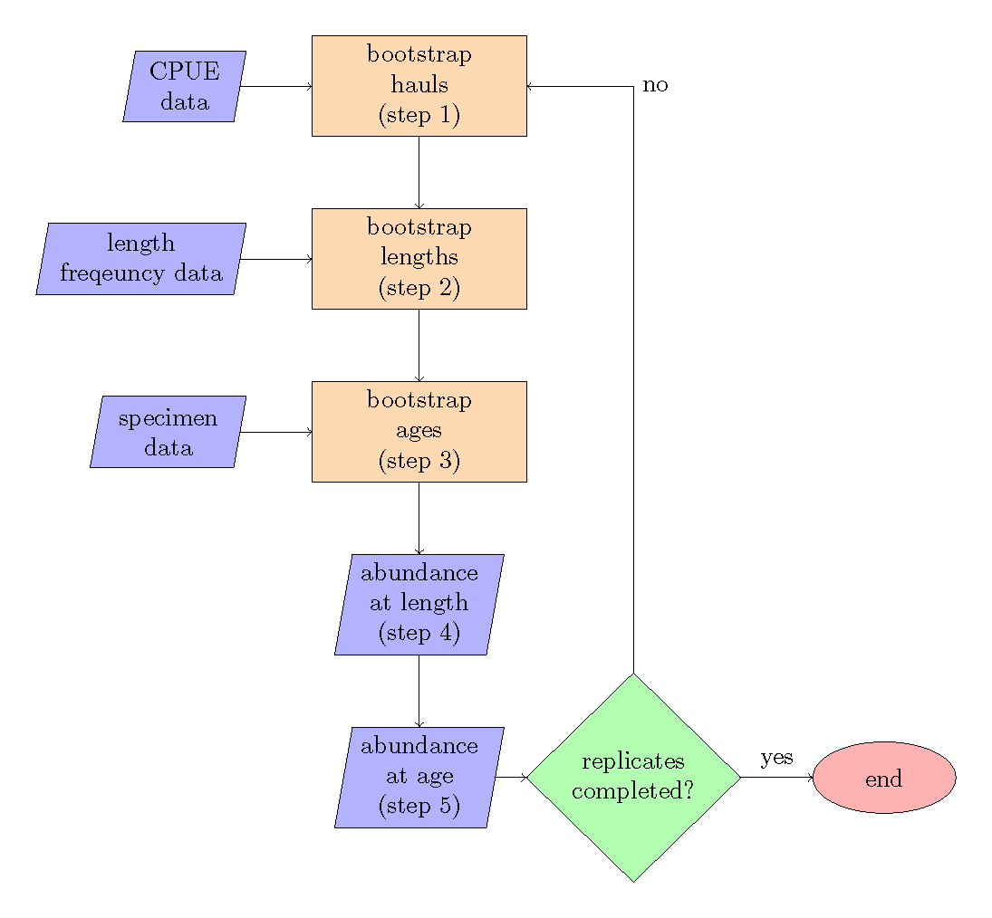

Figure 1. -- Bootstrap flow chart, the steps refer to the order of operations.

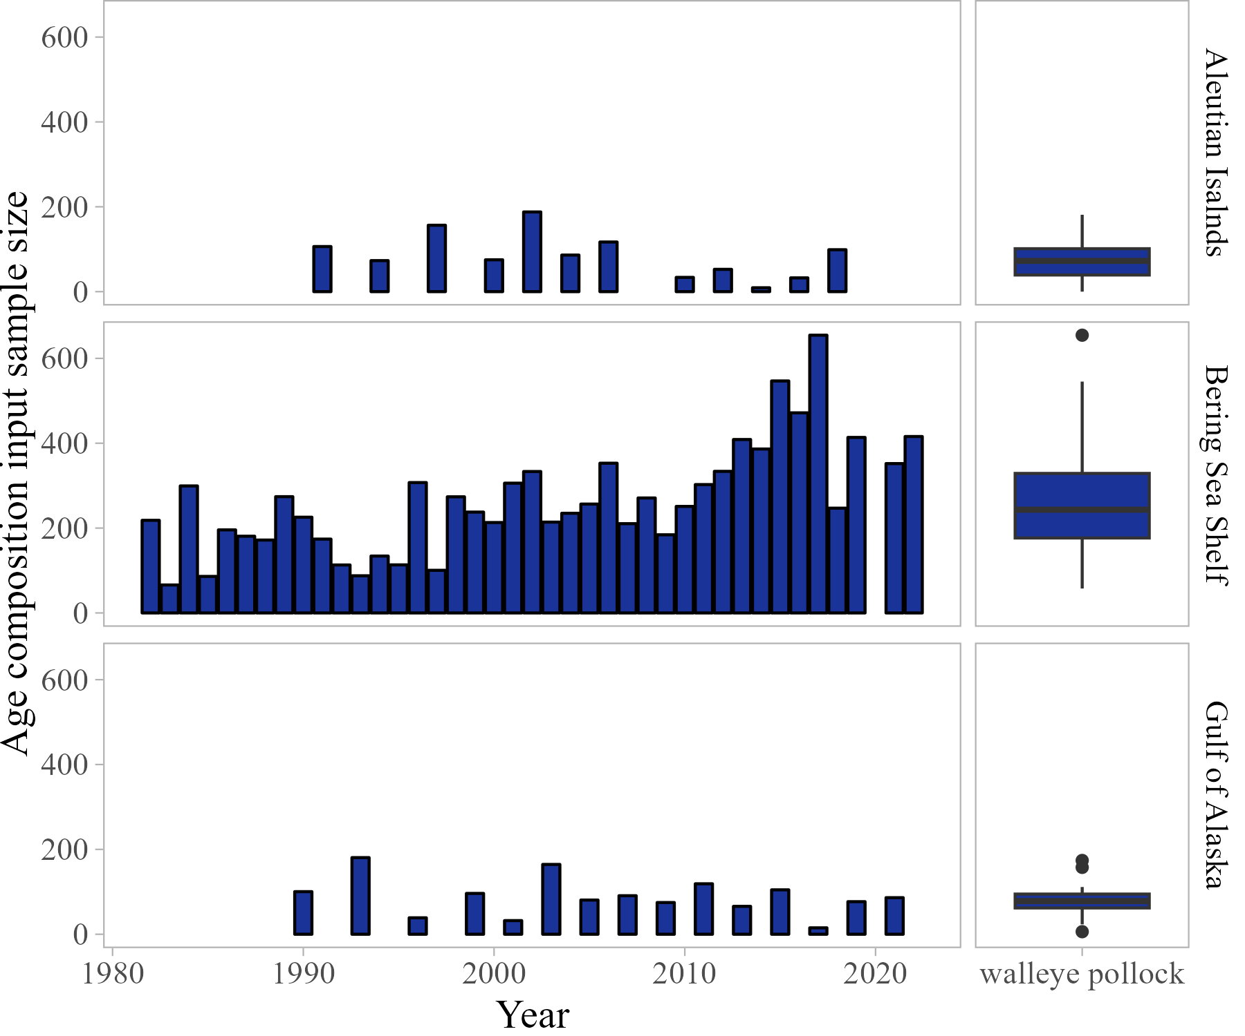

Figure 2. -- Walleye pollock total age composition input sample size by year and survey. Left panel shows age composition input sample size by year, right panel shows boxplot of combined annual input sample size with median (solid line), inter-quartile range (box), and 95th percentile range (whiskers).

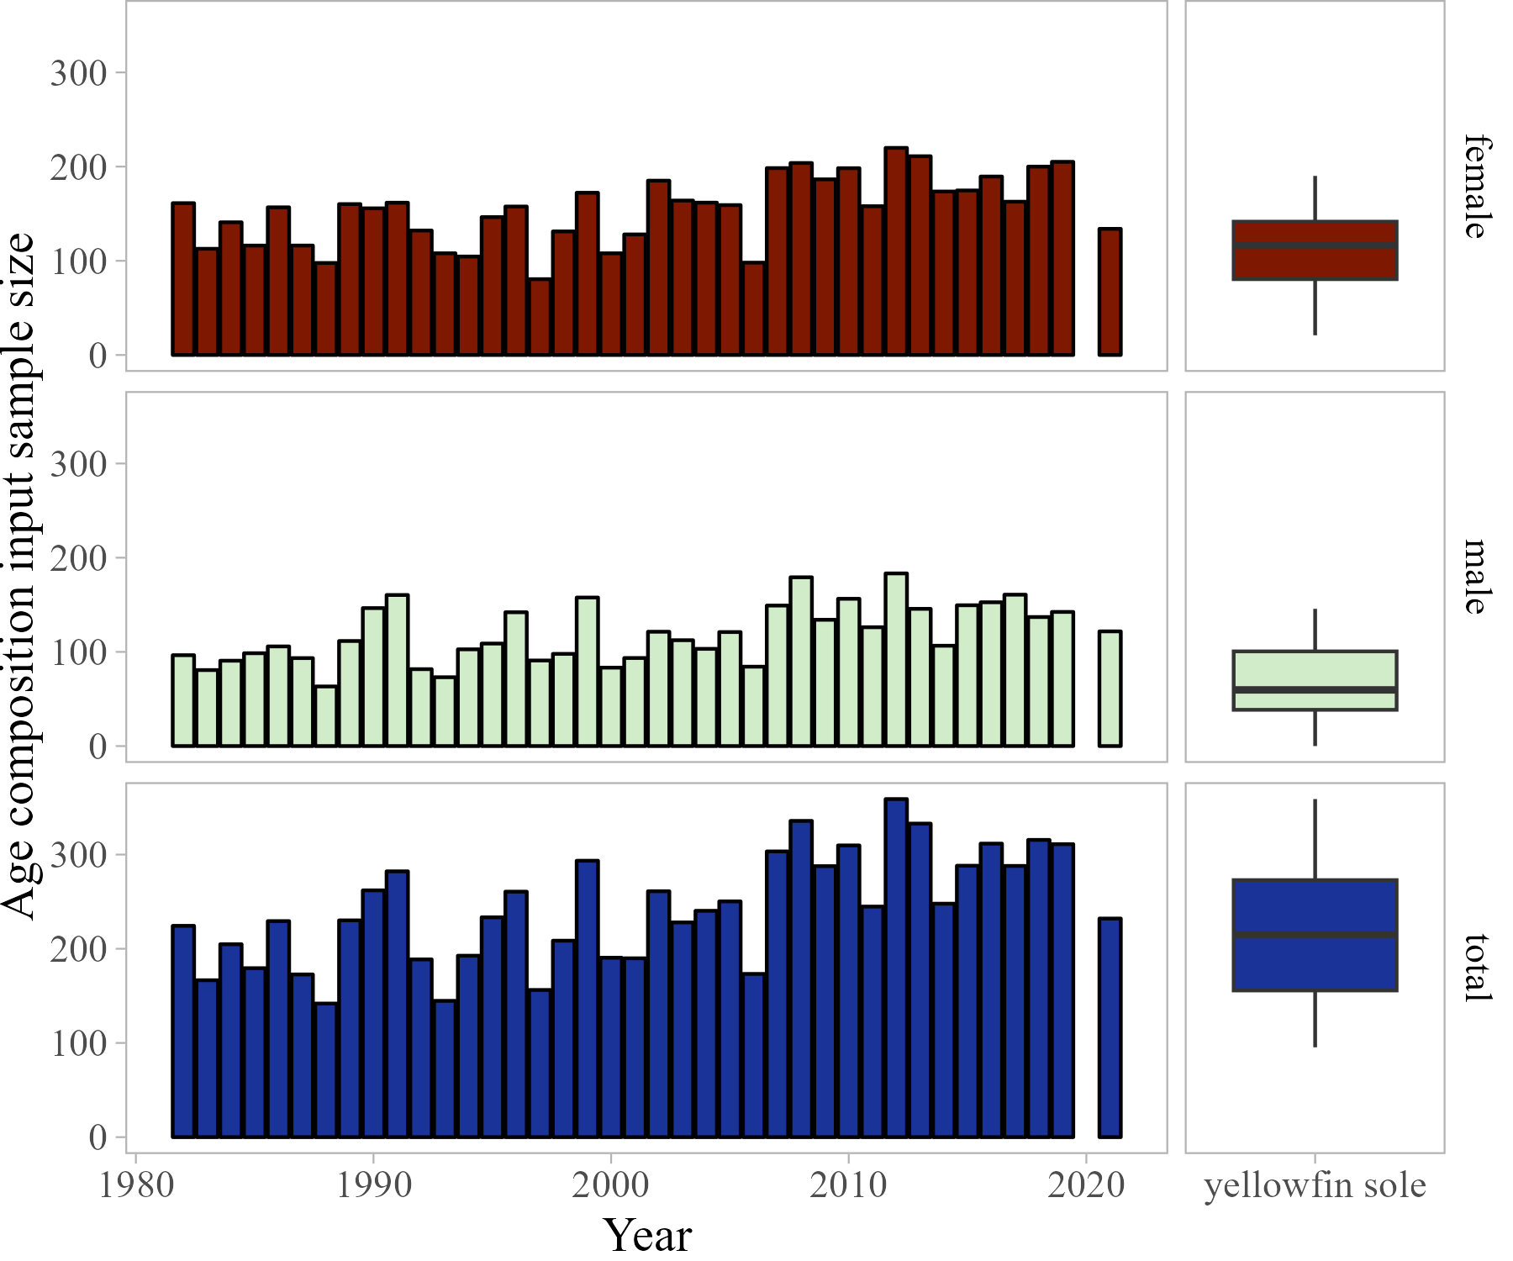

Figure 3. -- Eastern Bering Sea Yellowfin sole sex-specific age composition annual input sample size. Left panel shows age composition input sample size by year, right panel shows boxplot of combined annual input sample size with median (solid line), inter-quartile range (box), and 95th percentile range (whiskers).

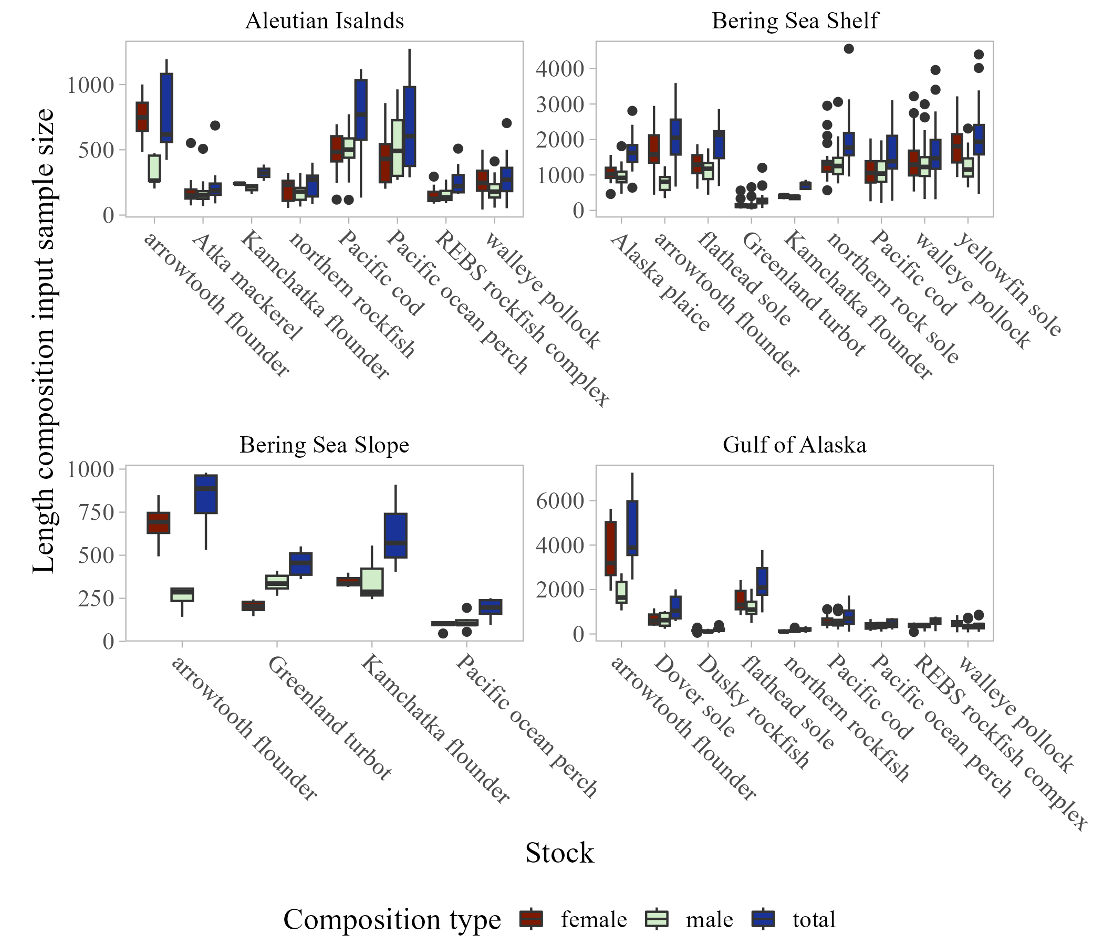

Figure 4. -- Length composition input sample size by stock and survey.

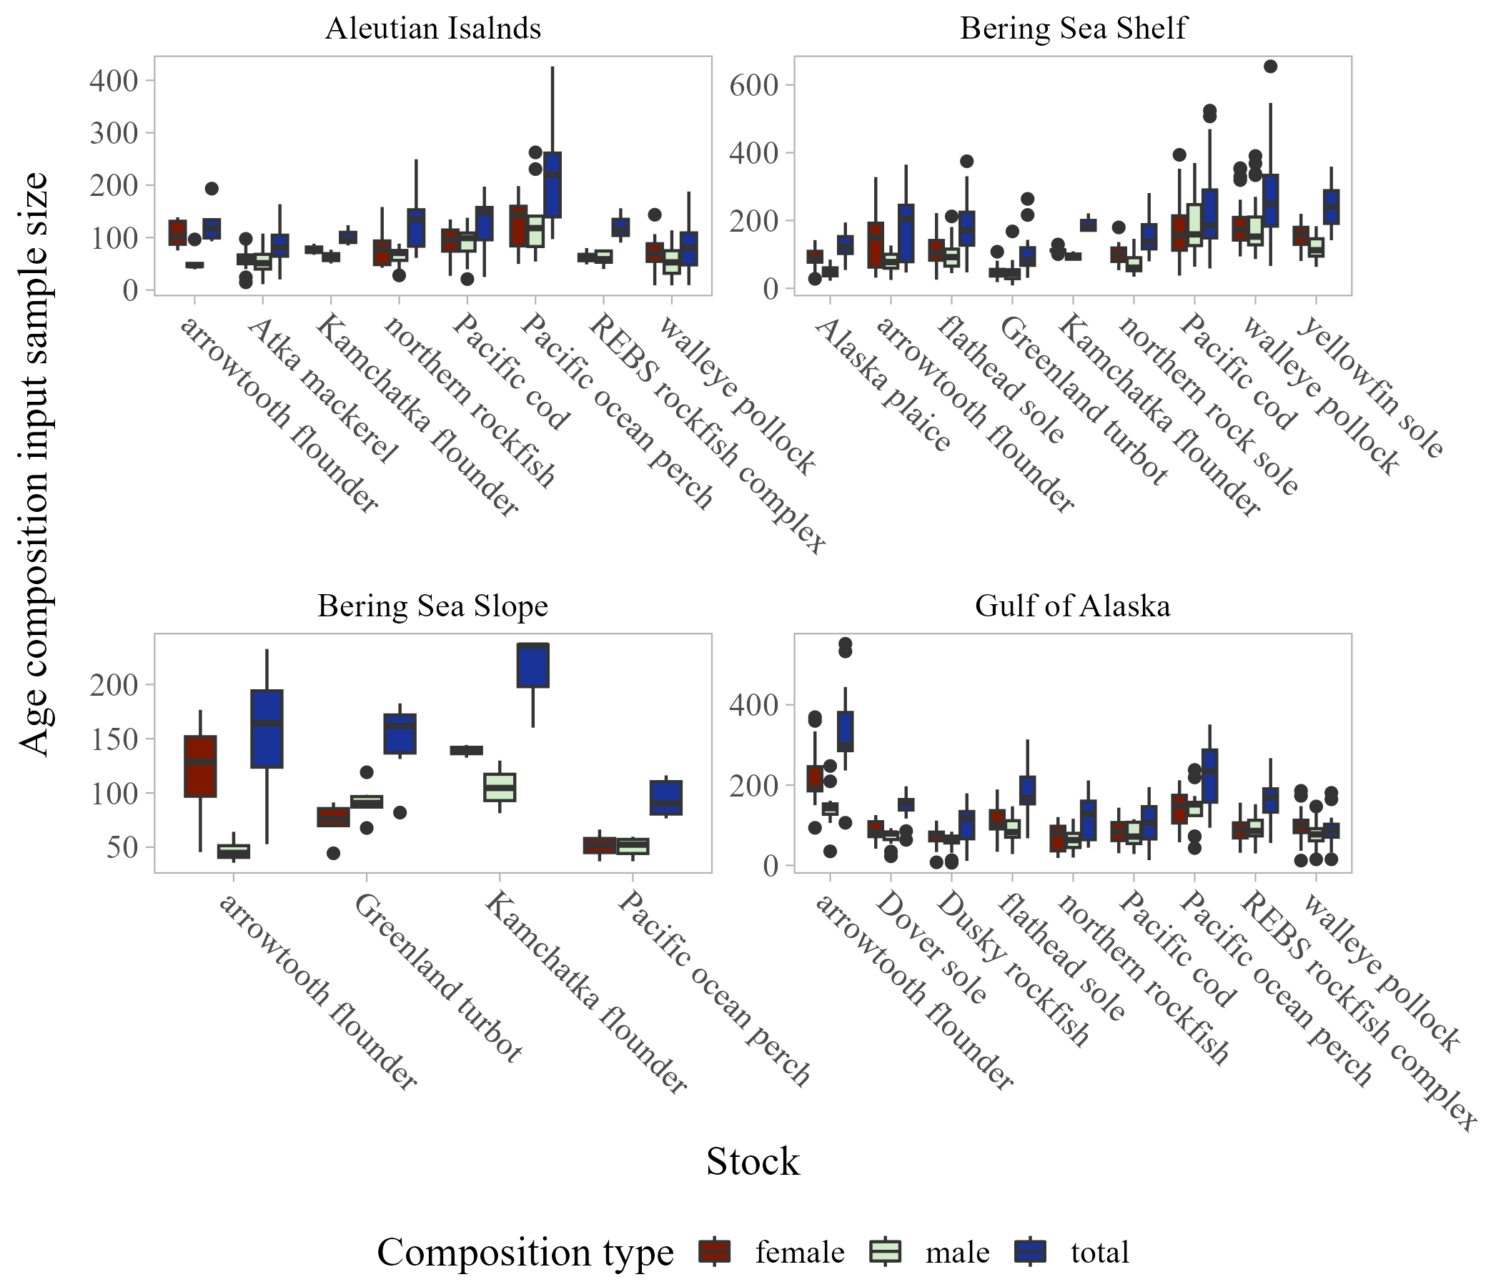

Figure 5. -- Age composition input sample size by stock and survey.

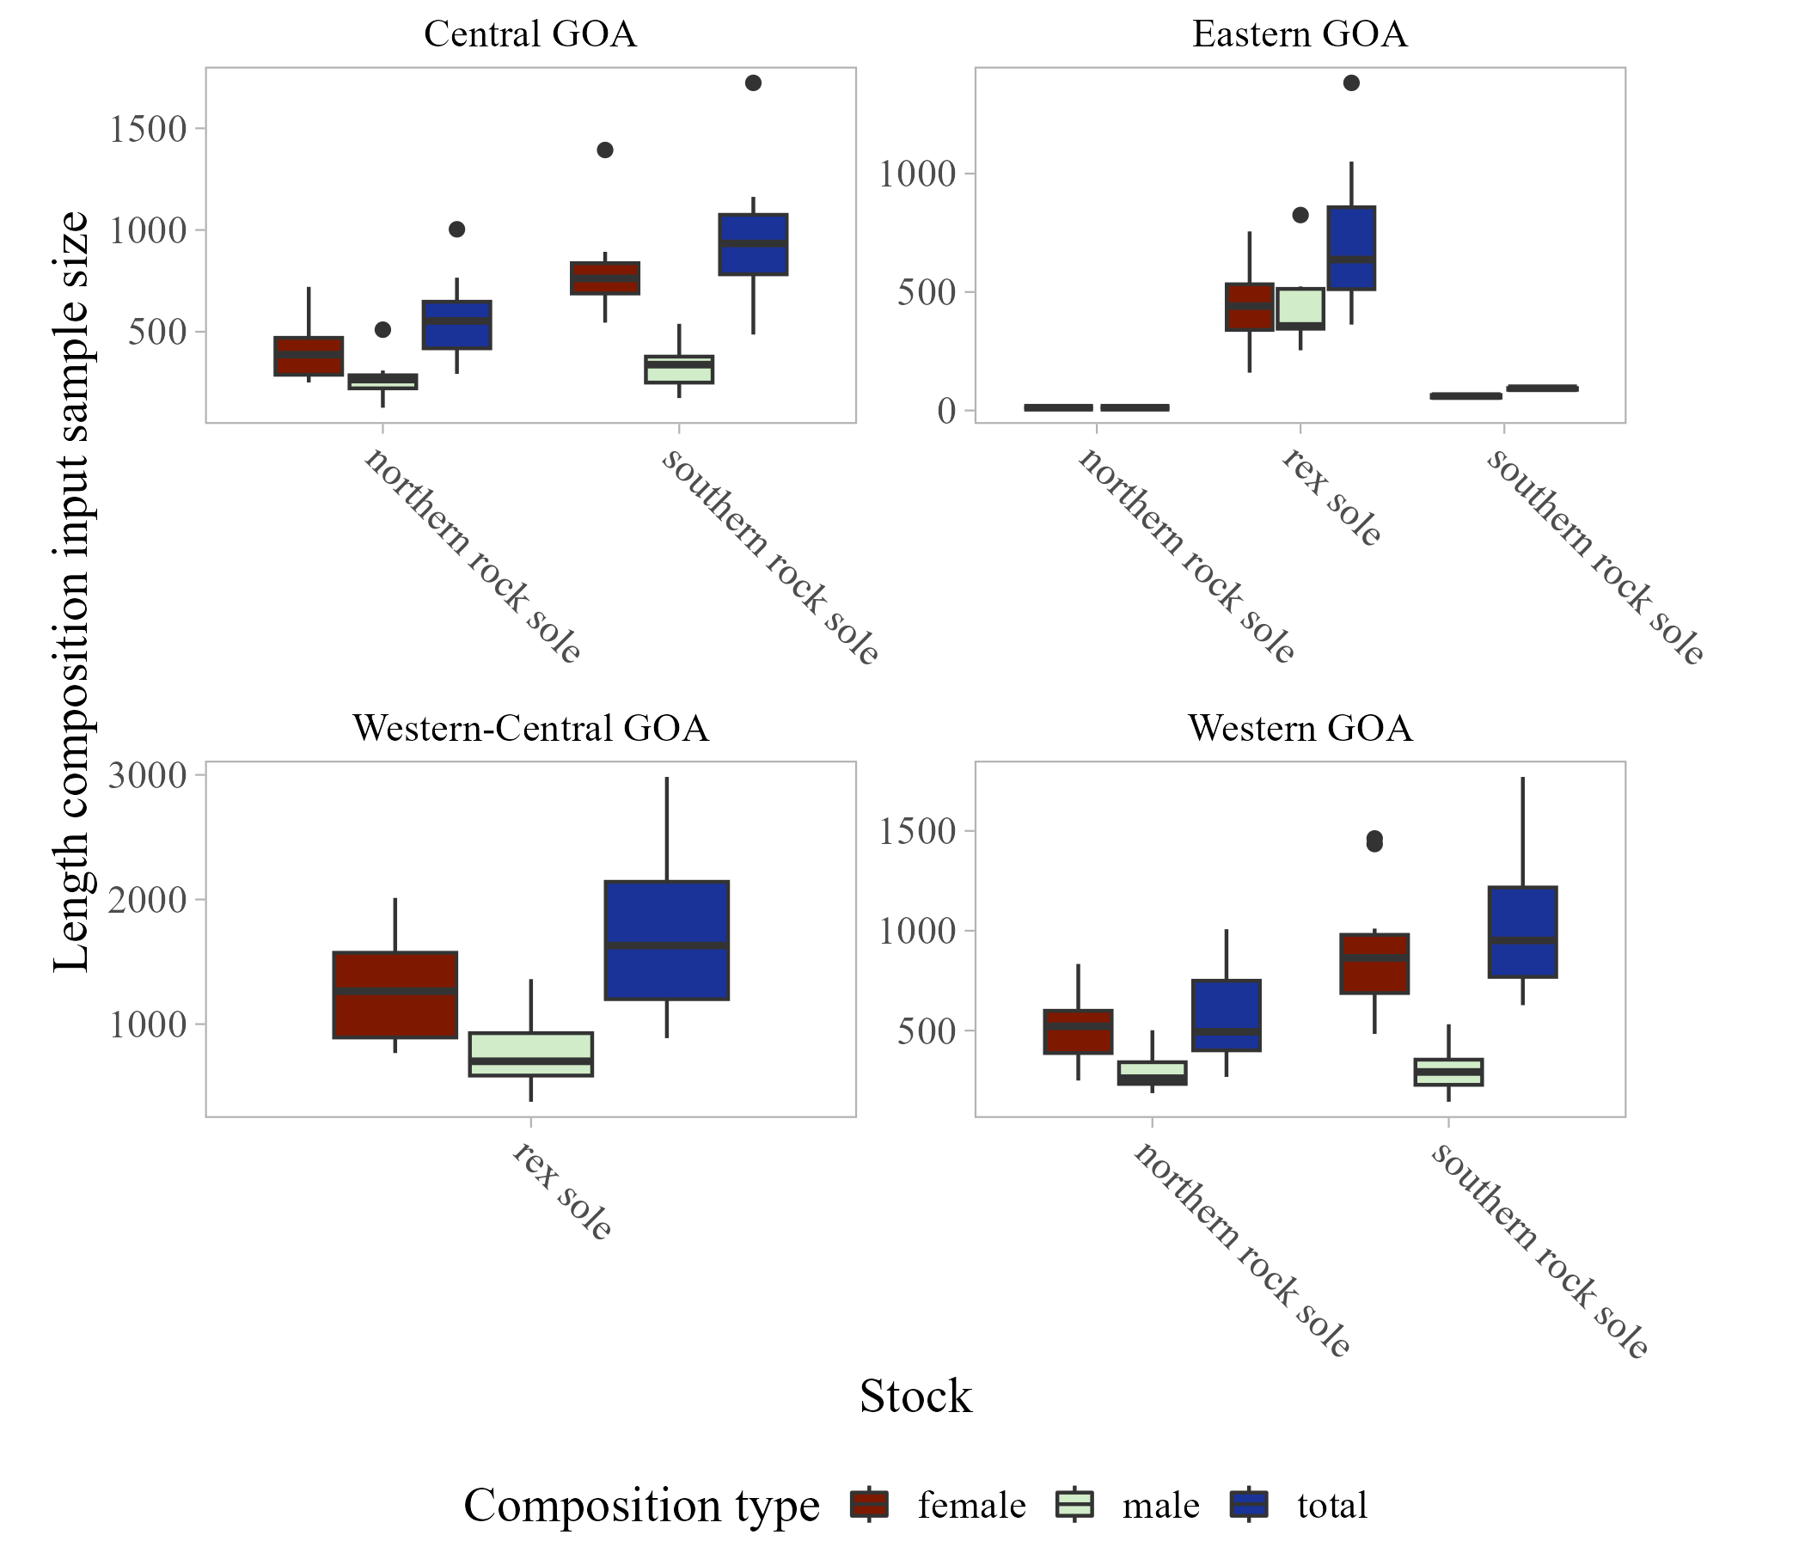

Figure 6. -- Sub-region length composition input sample size by stock within the Gulf of Alaska survey.

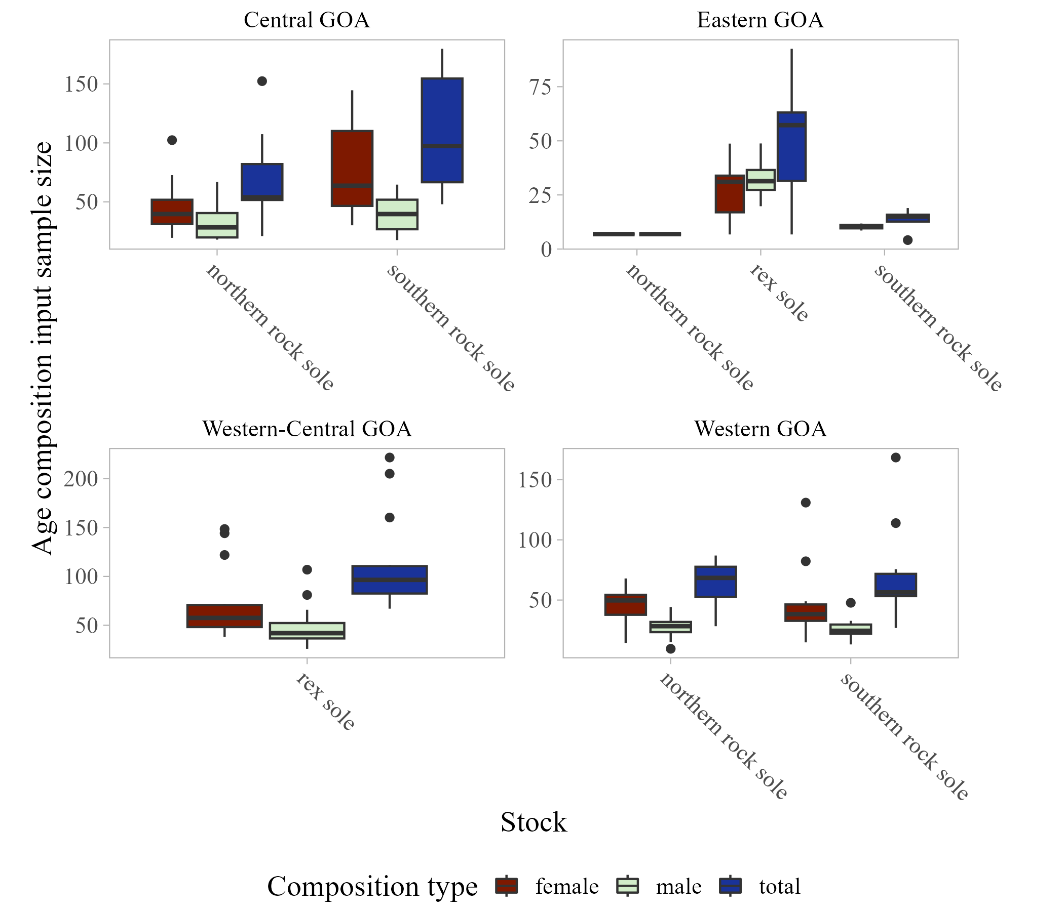

Figure 7. -- Sub-region age composition input sample size by stock within the Gulf of Alaska survey.

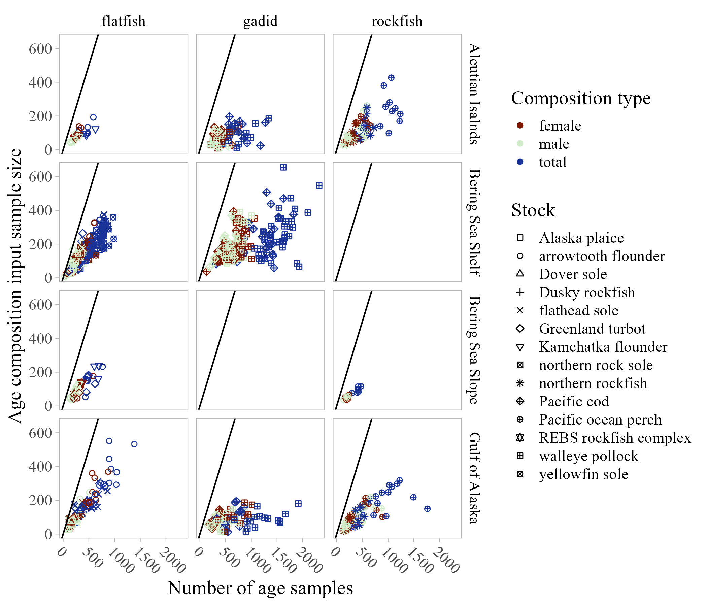

Figure 8. -- Number of fish aged and age composition input sample size by species group and survey (1-1 line shown in black for reference, gadids are not captured in the Bering Sea slope survey).

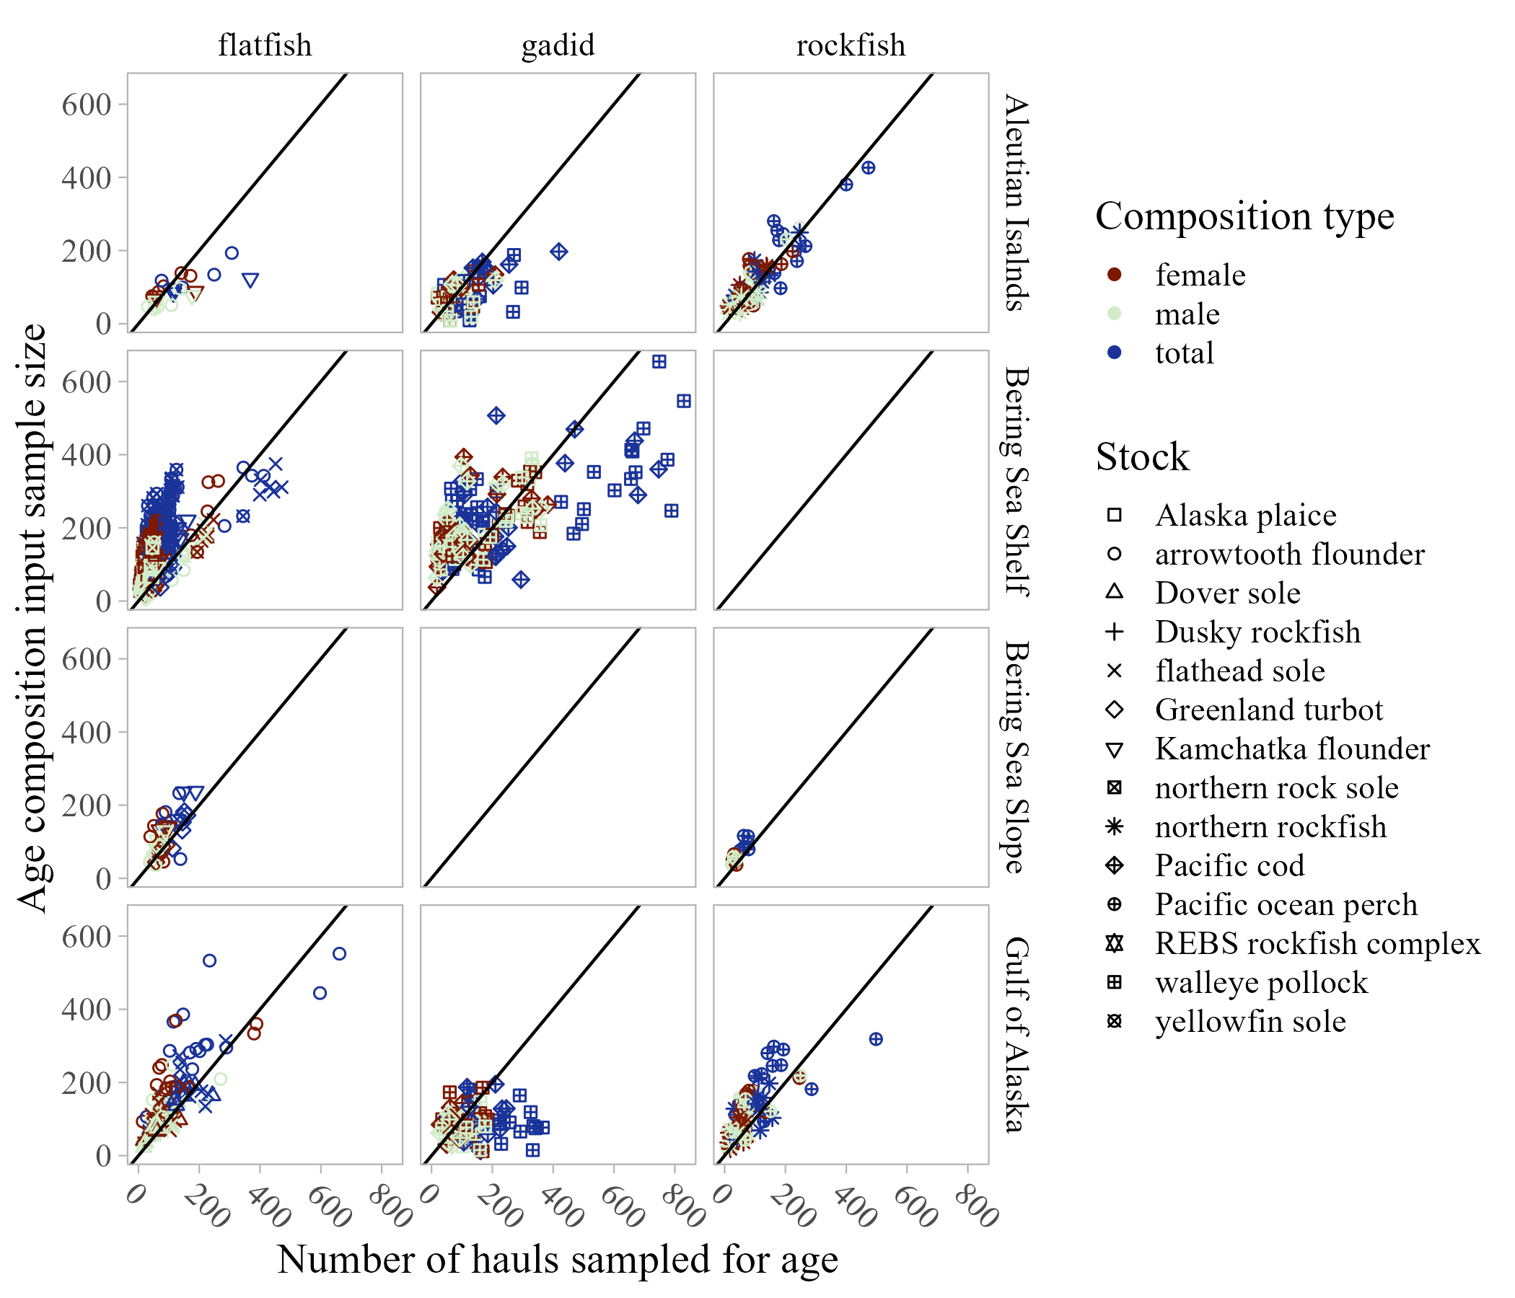

Figure 9. -- Number of sampled hauls compared to age composition input sample size by species group and survey (1-1 line shown in black for reference, gadids are not captured in the Bering Sea slope survey).